On Windows Node

Step:1 Go To Jenkins Server Dashboard Click On Manage Jenkins

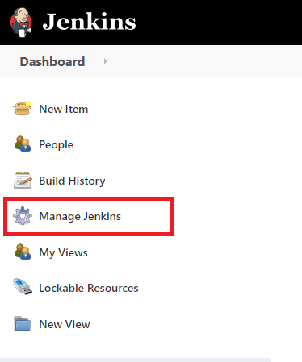

Step:2 Click On Manage Nodes

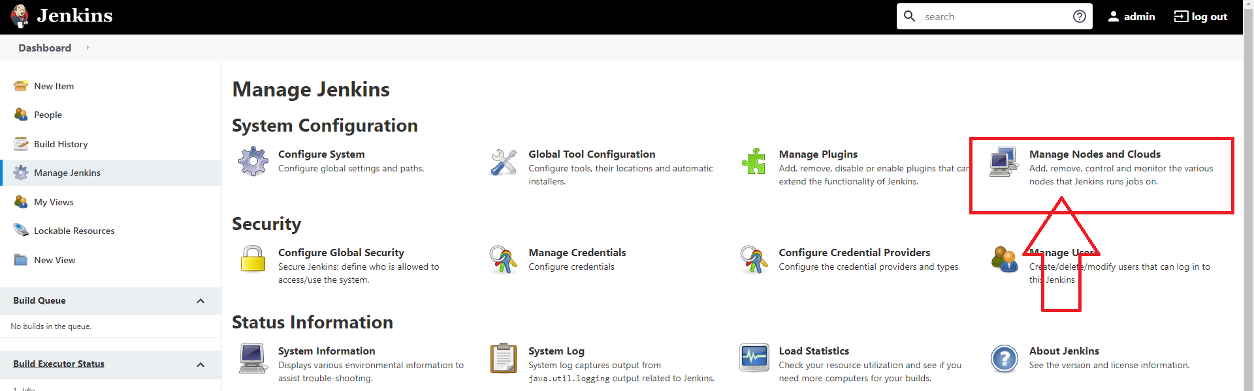

Step:3 Click On New Node

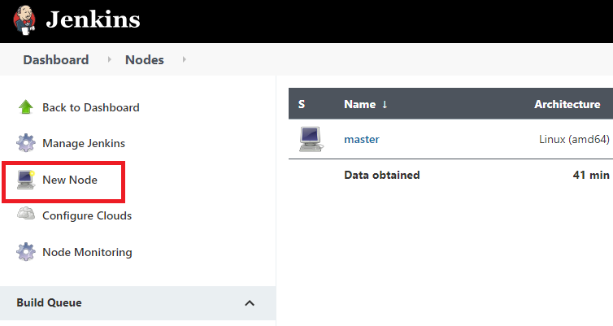

Step: 5 Give A Name To Node And Click On Permanent Agent And Ok **Windows-Node**

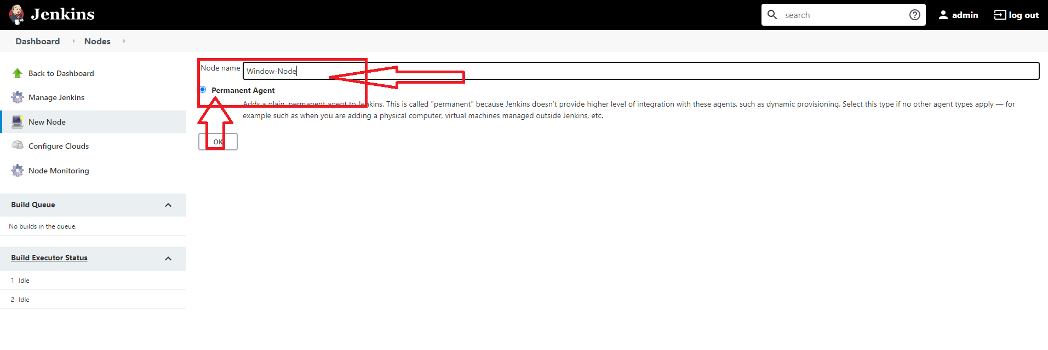

Step:6 Enter # of Executors **2**

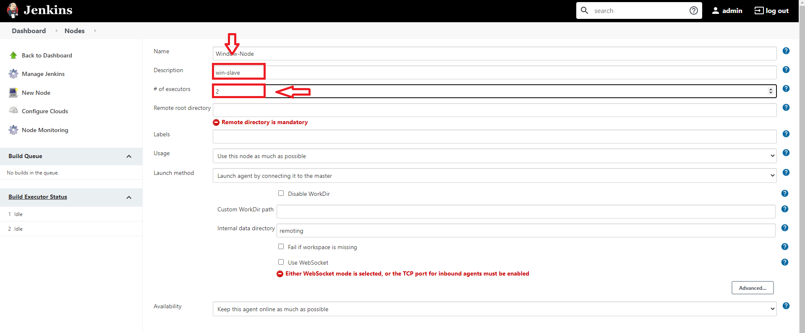

Step:7 Remote Working Directory **C:\Users\Administrator\Documents**

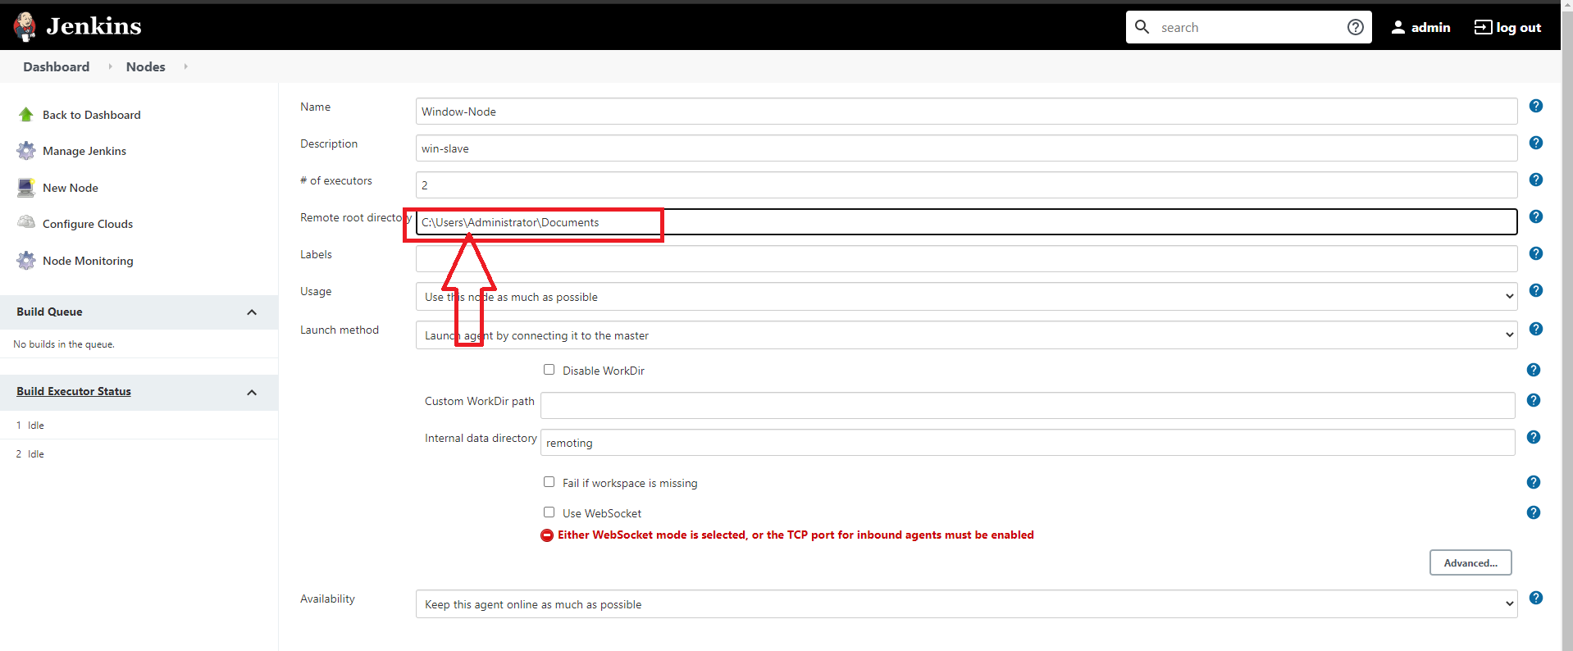

Step:8 Label As **remote**

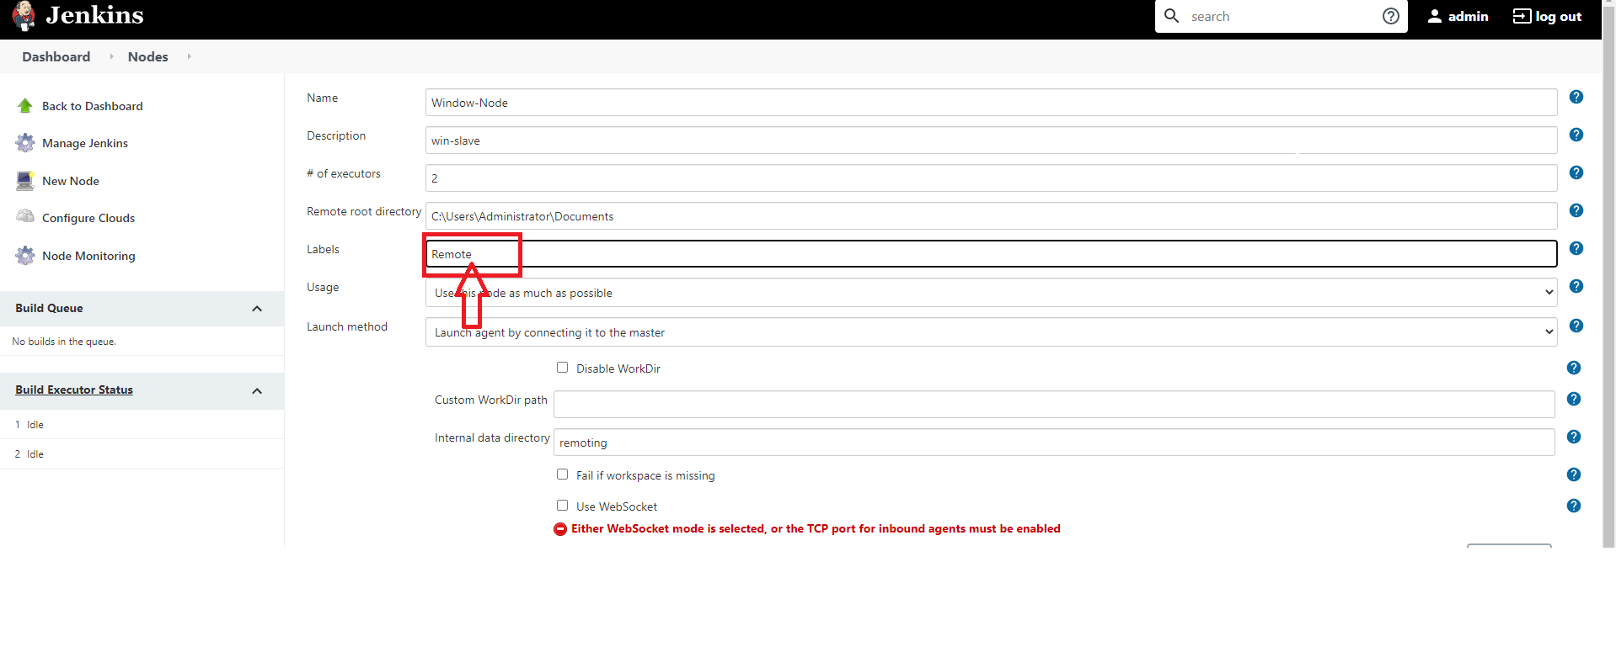

Step:9 Go Down And Select Node Properties And Chech Tool Locations Box and Click On Add

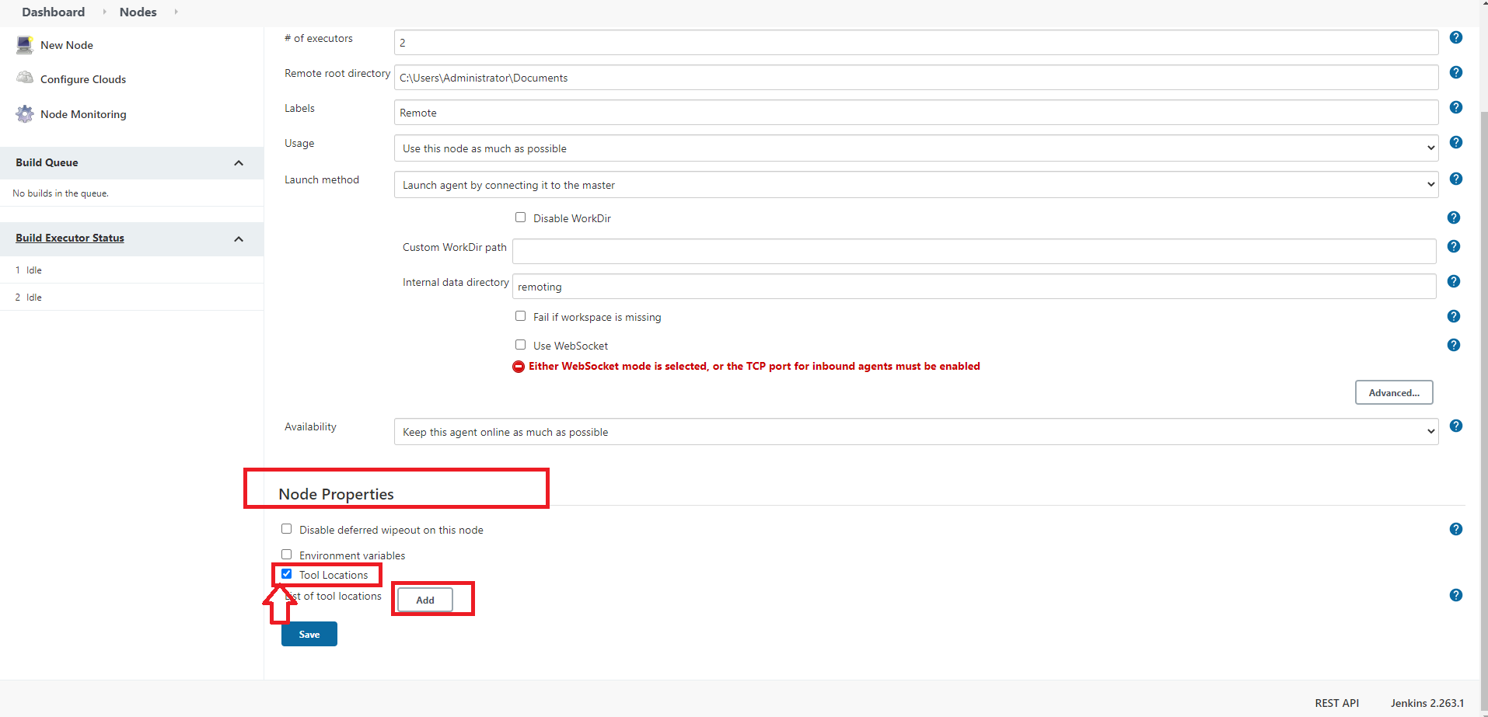

Step:10 Select Git As Name And Give Location **C:\Program Files\Git\bin\git.exe**

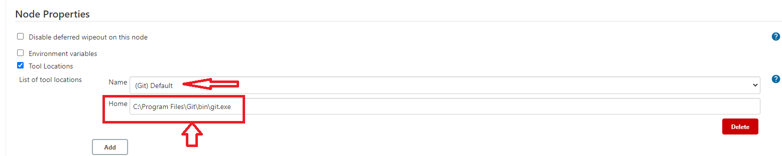

Step:11 Click On Save

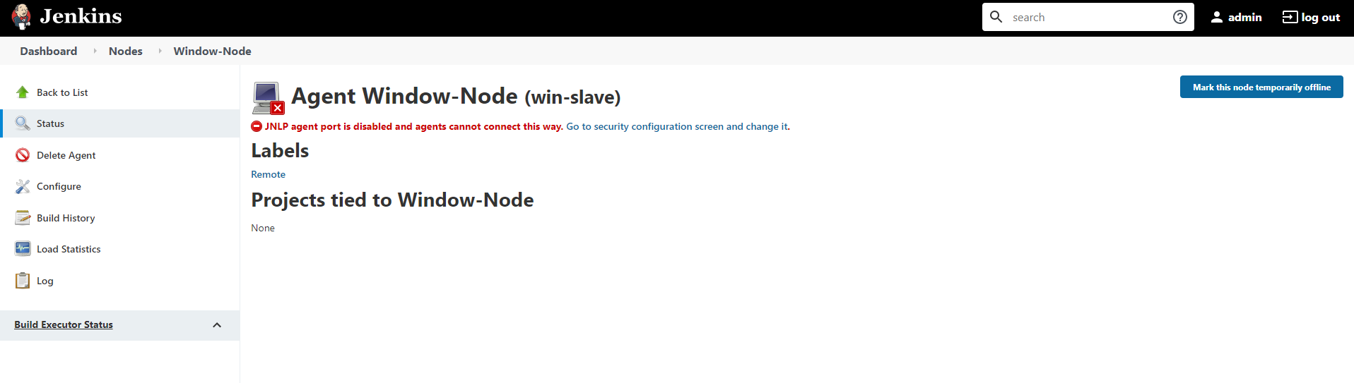

---------------------------------------End Of Adding Windows Node (A)---------------------------------------